Through the use of a Hardware Description Language (HDL), circuits can be rapidly designed and tested. Basic gates can be written using various forms of logical analysis. The simulation software, Modelsim, allows for easy simulation of a circuit written in the Verilog HDL
Lab
Thomas Cooper
Computer Engineering Major

INTRODUCTION
THE first lab is an introduction to the simulation software, and the Verilog HDL. Very simple tasks have been assigned to guide students through creating a project, compiling modules, and simulating the language. Last, results are extrapolated from the software using truth tables, and wave outputs.

Task #1
Lab 1 begins by tasking the student with creating an empty project. Modelsim has a standard interface. Toolbars at the top, windows in the middle, outputs and status information at the bottom.
To create a new project, the user goes to file on the menu bar, highlight new, and select new project. Modelsim responds by opening a small window where the user can input the project name, and configure the location of the project files.
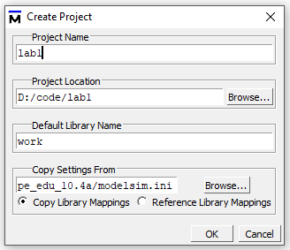

Task #2
Task two states to create two new files for each basic gate AND, OR, and NOT. Then two different methods are implemented for each type of gate.
AND1
module AND1 (output oand1, input A, B);
assign oand1 = A & B;
endmodule

OR1
module OR1 (output oor1, input A, B);
assign oor1 = A | B;
endmodule

NOT1
module NOT1 (output wire onot1, input A);
assign onot1 = ~A;
endmodule

Very simple statements that assign the output of the gate to the bitwise logical operation of the inputs with their respective gate.
AND2
module AND2 (output reg oand2, input A, B);
always @(A,B)
case ({A,B})
2'b00:oand2=0;
2'b01:oand2=0;
2'b10:oand2=0;
2'b11:oand2=1;
endcase
endmodule

OR2
module OR2 (output reg oor2, input A, B);
always @(A,B)
case ({A,B})
2'b00:oor2=0;
2'b01:oor2=1;
2'b10:oor2=1;
2'b11:oor2=1;
endcase
endmodule
NOT2
module NOT2 (output reg onot2, input A);
always @(A)
case ({A})
1'b0:onot2=1;
1'b1:onot2=0;
endcase
endmodule

This approach uses a case switch method to concatenate the values the state of the inputs and logically runs down the list of results until it has the matching output.

Task #3
Next, the lab states to write an additional testbench file to simulate the code written for the gates in the previous task. The testbench will need to test every possible state for the inputs.
`timescale 1ns / 1ns

module testbench;
reg a, b;
wire oand1, oand2, oor1, oor2, onot1, onot2;
AND1 a1(oand1,a,b);
AND2 a2(oand2,a,b);
OR1 o1(oor1,a,b);
OR2 o2(oor2,a,b);
NOT1 n1(onot1, a);
NOT2 n2(onot2, a);
initial
begin
#10 a=0; b=0;
#10 a=0; b=1;
#10 a=1; b=0;
#10 a=1; b=1;
#10 a=0; b=0;
end
initial
$monitor($stime,, a,, b,, oand1,, oand2,, oor1,, oor2,, onot1,, onot2);
endmodule

This set of code starts by setting the timescale to 1 nanosecond, with a 1 nanosecond resolution on the measured inputs and outputs. The inputs a and b are declared, and then the outputs oand1 and 2, oor1 and 2, and onot1 and 2. The preprogrammed state changes are then assigned to the inputs. The #10, which means “for the next amount of time units” (in this case in nanoseconds). The inputs are set to make changes every 10 nanoseconds. What follows is setup like a truth table where the inputs are assigned binary values dependent on placement in the table.
Finally, the file finishes with monitoring of all inputs and outputs.

Task #4
With the testbench created, the gates are simulated with all possible input state combinations. The output is displayed using two methods.

Truth Table
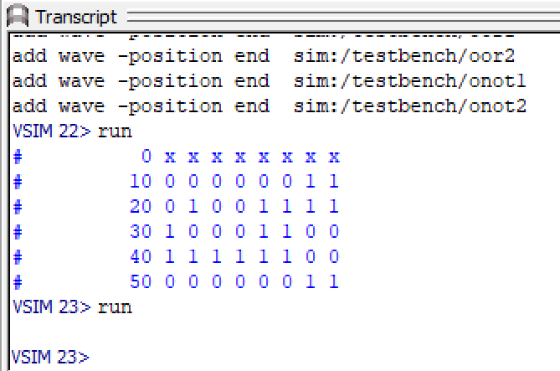

Wave Form
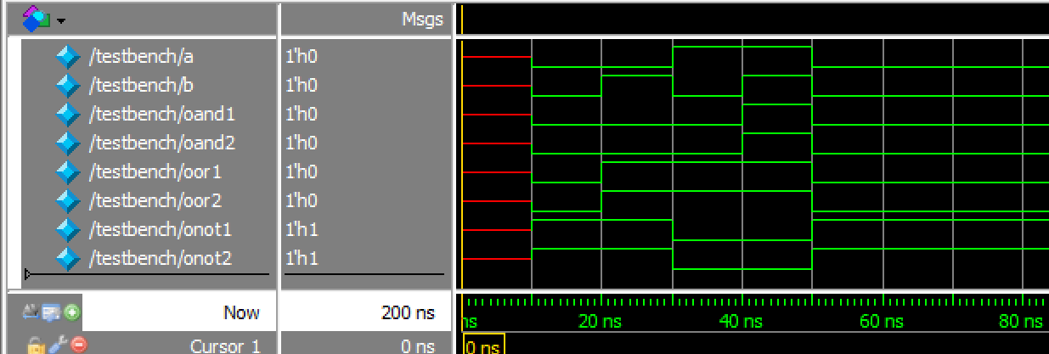

In the truth table, the first two columns represent the state if the inputs with the first column designated input a, and the second column input b. The rest of the columns are outputs oand1 and 2, oor1 and 2, and onot1 and 2. The two not gates are monitoring the state of input a.

Task #5
Finally, the results are interpreted. Looking at the truth table, it is evident that all gates are functioning correctly. The testbench has fully verified all of the gates as every possible combination of inputs has been simulated, and has provided the correct associated output.

Results
The first lab was designed to be an introduction to the Verilog HDL, and to Modelsim. The process was not without difficulties. There were issues at first with simulating the code, as the development environment was unfamiliar. An issue was occurring at first due to an assumption in the compiling process and saving the source code. There was an additional error when instantiating the gates in the testbench. Different naming conventions for the declaration of the gates in the testbench resolved the errors.
The process of synthesizing and monitoring the outputs encountered errors as well. Modelsim requires explicit instruction to monitor the states of inputs and outputs. The wave forms have to be manually added.
References
- Provided class slides

 

